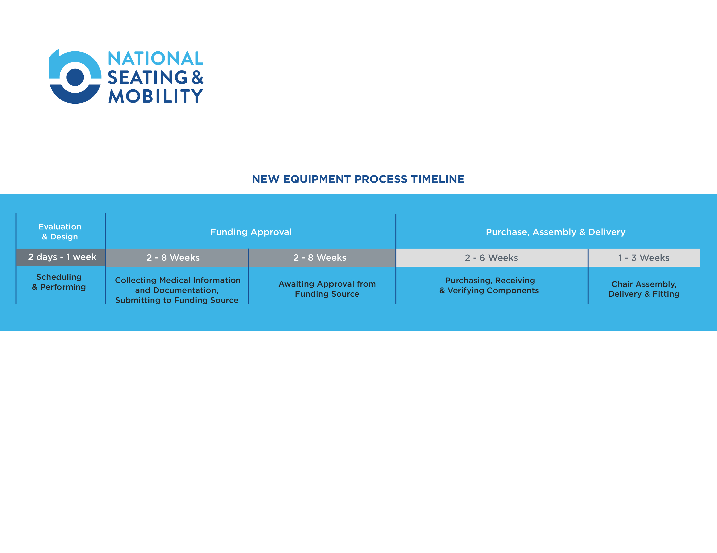

**Assistive Technology Professional (ATP)**

Don Maulucci, ATP,RTS: Cell 716-374-0542 Branch Phone: 716-674-0783

Email: don.maulucci@nsm-seating.com

**Service & Repair**

NSM 19 Ransier Drive West Seneca, NY 14224: 716-674-0783

**Home & Vehicle Accessibility**

Access Division 716-674-0783

19B Ransier Drive West Seneca, NY 14224 Phone: 716-674-0783 • Fax: 716-674-0784 Hours of Operation: M-F 8:30am – 5:00pm

Visit mynsmorder.com to check the status of your order.

To access order, enter Order ID #________________ and Client’s Last Name

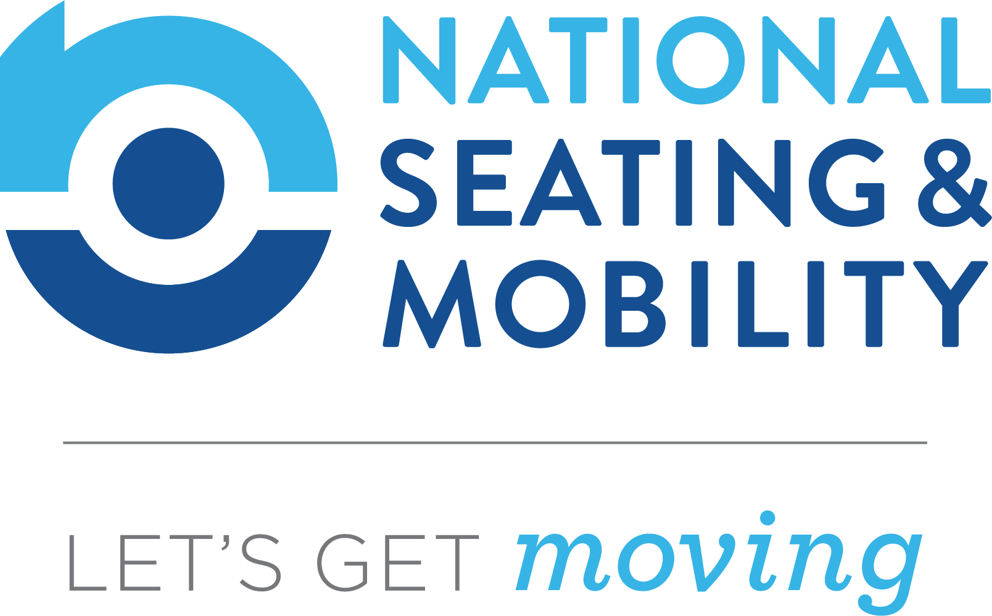

You can depend on your NSM Care Team to be efficient, knowledgeable and reliable. From evaluation to delivery, we will ensure the process is seamless as we customize a mobility solution specifically for your needs. We look forward to serving you!

**Your NSM Care Team**